1. **Purdue model for Control Hierarchy**

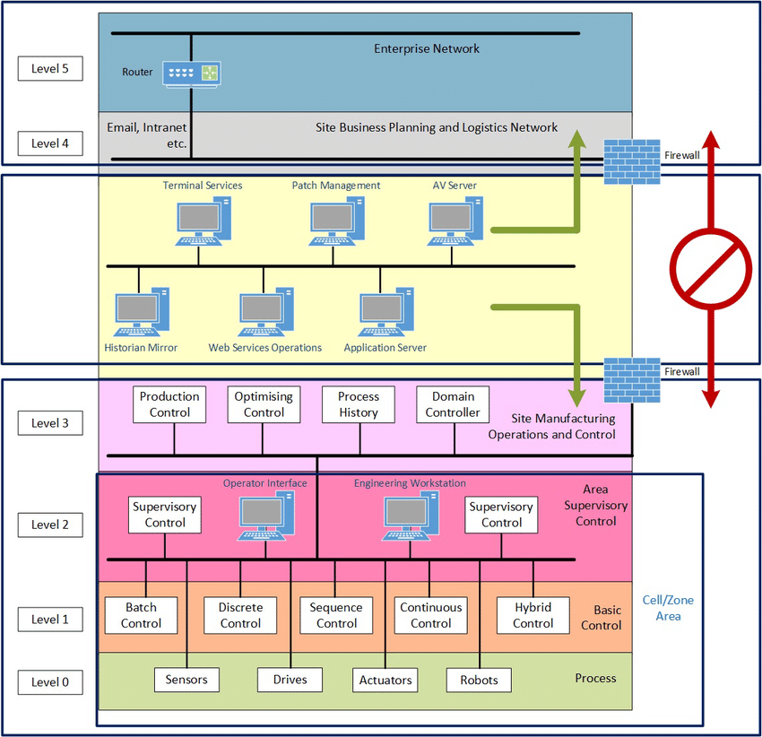

**Level 5** describes the corporate or enterprise network of an organisation running its **business management** **applications and services**. Internet access exists within this layer. **Level 4** shows the services to manage the **planning, scheduling and logistics of the operations**. **Level 3** encompasses the management of the **day-to-day** **industrial operations of the facility**, including **production scheduling**, **quality assurance**, process optimisation etc. **Level 2** provides supervisory control of the equipment involved in the **overall industrial process**. **Level 1** **encapsulates the control of individual devices** and equipment involved in discrete elements of the overall process. **Level 0** includes the devices, sensors and associated equipment performing the industrial process.

**2.Industrial Internet Reference Architecture (IIRA) by industrial internet Consortium (IIC)**

A reference architecture provides guidance for the development of system, solution and application architectures. A reference architecture provides a common framework for more detailed discussions. By staying at a higher level of abstraction, it enables the identification and comprehension of the most important issues and patterns across its applications.

**Example**

A reference architecture for a residential house state that all residential houses need to provide one or more bedrooms, bathrooms, a kitchen and a living area. This set of rooms is accessible inside the house through doors, hallways, and stairways, and from outside through a main and a back door. The house provides a safe environment against threats such as fire, hurricanes and earthquakes. The structure of the house needs to sustain snow and wind load that may be found in its local environment. The house needs to provide reasonable measures to detect and prevent unauthorized intrusions.

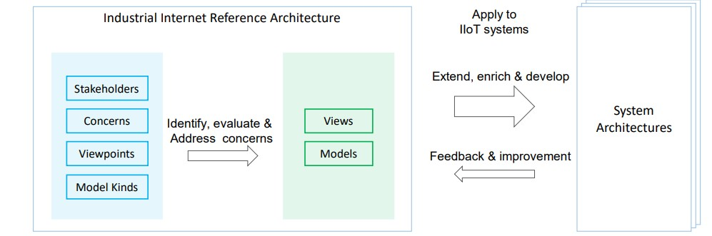

The purpose of the IIRA is to provide **guidance to system architects to assist the architects in building IIOT systems. (Conceptual view, Business view, User view, Functional view and finally Implementation view**)

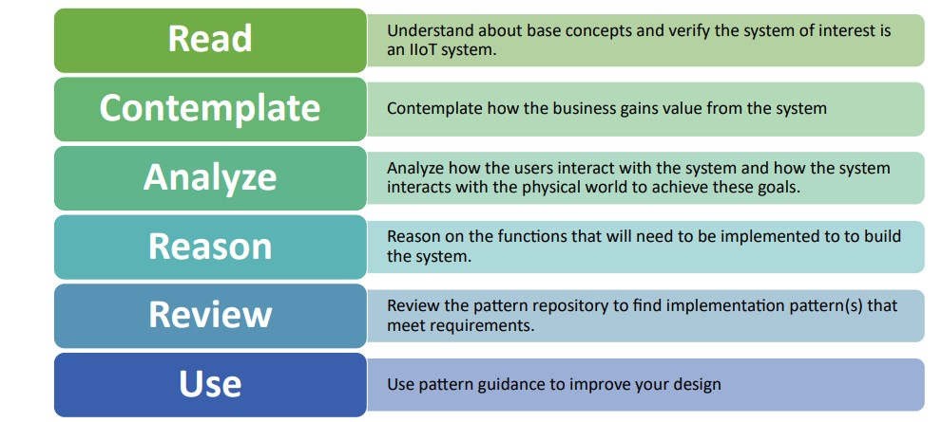

**3. Internet of Things – Architecture (IOT-A)**

